Site Designer March 2026 Release Notes

SD-376 New Mailto Element. A Mailto element has been added to allow a user to create a mailto link and specify the subject, one or more email recipients, Cc and Bcc lines, and a body.

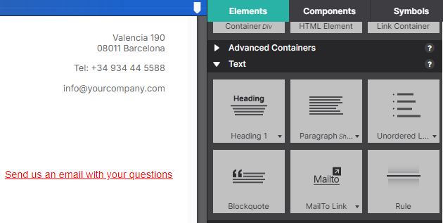

The “mailto” fields can be entered or edited in the element properties pane.

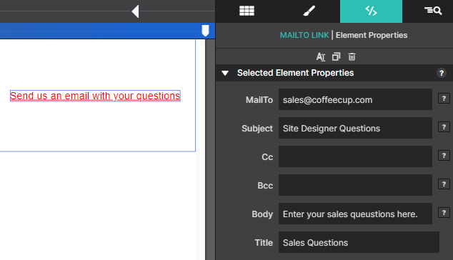

The Cc, Bcc, and Body fields are optional.
A multi-line body can be specified by using “/n” as a line separator.
For example, if body is:
“Hello customer support,\nPlease send me the user guide for your coffeemaker model CC1250”
The email body will be:
Hello customer support,
Please send me the user guide for your coffeemaker model CC1250
On preview or export, a proper html “mailto” link is created. Note that text is url-encoded.
<a class="link-mailto mailto-link-1"
href="mailto:sales@coffeecup.com?
Subject=Site%20Designer%20Questions&amp;
body=Enter%20your%20sales%20queustions%20here."
id="test-email" title="Sales Questions">Send us an email with your questions</a>
When the link is clicked, the mail app pops up with mail fields pre-populated.

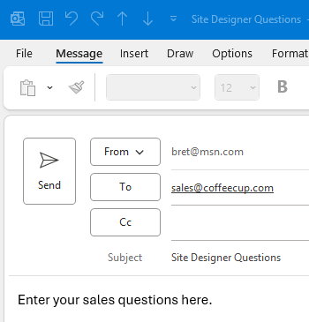

SD-29 New Image Element. The image element is used to add a regular image (`<img>`) to the canvas without a wrapper (unlike the existing picture element that includes a div wrapper).
The image element is useful for cases where full control of the image element itself is required. For example, custom JavaScript code or a JavaScript plugin may require access to the image id, class, etc. This is not possible with the picture element which has a div wrapper around it.

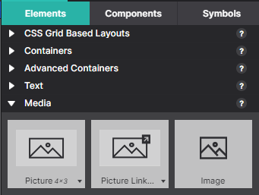

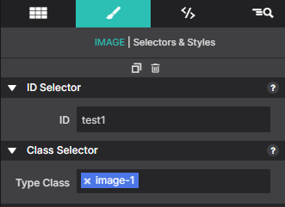

The generated html will look like this (just an img element with no wrapper):
<img class="responsive-image image-1" alt="Placeholder Image" src="./images/neonbrand.jpg" id="test1">

SD-377 Allow users to remove empty breakpoints. Added Actions menu item to remove empty breakpoints.
Sometimes, empty breakpoints can exist due to user error or by moving styles of one breakpoint to another. Empty breakpoints can be removed by selecting Actions->Remove_Empty_Breakpoints.

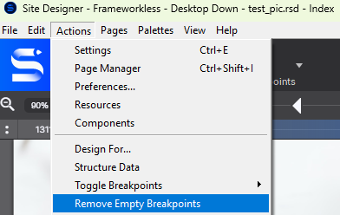

Default breakpoints or any of the fixed breakpoints for each framework will not be removed.

SD-371 Added Open Graph Twitter Cards control to Page Manager.
Added a new section “Twitter/X Cards Settings” to the Open Graph area in Page Manager. Added a new control
“X Card Type“ for adding a Twitter card.
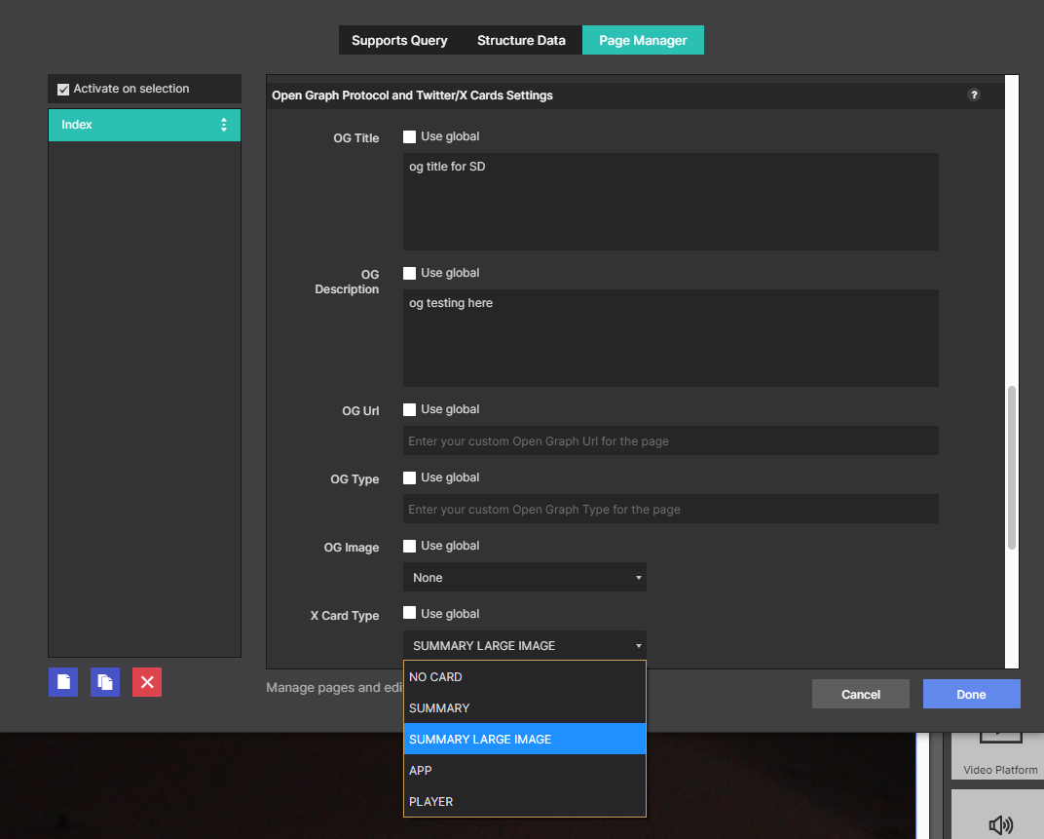

To configure a twitter/X card, select one of the card types from the X Card Type list. The available card types are “summary”, “summary_large_image”, “app”, or “player”. Choose “NO CARD” to disable twitter cards.
The generated html markup in the page head section will look like this:
<meta name="twitter:card" content="summary" />
Open Graph settings used with twitter cards.
For summary and summary_large_image types, the following Open Graph settings are required:
- og:title
- og:description
- og:image
For type summary, the image should be square. For type summary_large_image, the image should be large and rectangular.
The twitter card types “app” and “player” do not have Open Graph settings. To use these types, some additional twitter-specific fields need to be added in the custom head section of the page manager.
The “app” type is used to promote an app available at the Apple store or Google Play. More information about the “app” settings can be found here: https://developer.x.com/en/docs/x-for-websites/cards/overview/app-card
The “player” type is used to play a video. More information about the “player” settings can be found here:
https://developer.x.com/en/docs/x-for-websites/cards/overview/player-card

SD-309 Open Preview from Custom Path – Enhanced to export PHP files.
In the previous release of Site Designer, a new feature was added to allow a custom path to be configured for preview (See https://www.coffeecup.com/forums/site-designer/site-designer-change-logs/?page=5).
This feature is now called “Live Preview”.
The feature has been enhanced to export PHP files into the custom export directory. This means that if you have a LAMP stack installed on your local PC or a local directory shared with a local Linux server, you can test both the front-end and back-end of your Site Designer project on your local machine.
Setup PHP on your local PC.
PHP-only
<link TBD>
PHP and MySql with XAMPP
<link TBD>

SD-381 Option to Specify a Base Url for Live Preview.
In order to properly test a PHP file with Live Preview, the browser needs to open an http or https url, not a file path.
A new field has been added to the Live Preview settings for this: Live Preview Server Url.
The url to the web server used for testing goes in this new field.

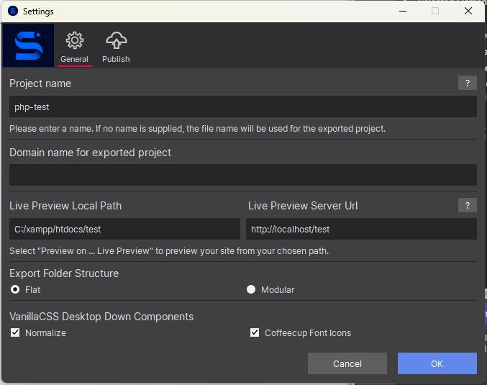

In the Settings page example above, XAMPP has been installed on the user’s PC.
The Live Preview Local Path has been set to c:\xampp\htdocs\test.
The Live Preview Server Url has been set to http://localhost/test so that the browser will open using the url for the web server configured on the local PC.

To test a PHP file, create a Site Designer page like this:
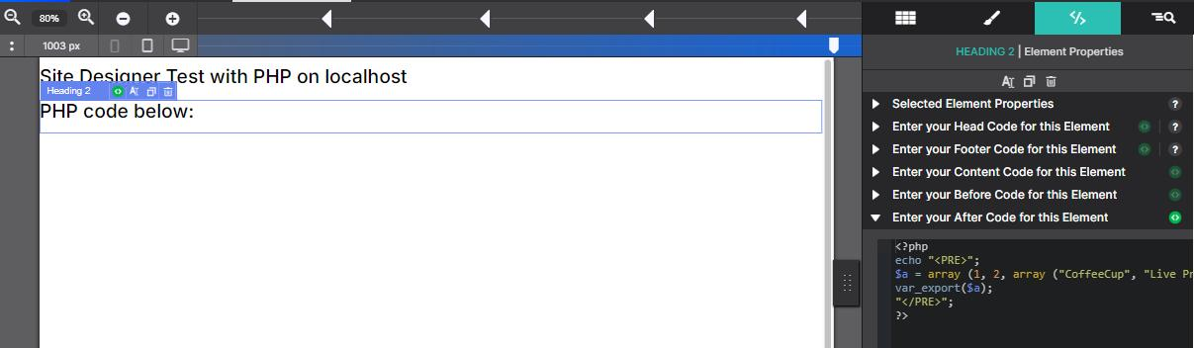
PHP code here

Enter the following for “Enter your After Code for this Element”:
<?php
echo "<PRE>";
$a = array (1, 2, array ("CoffeeCup", "Live Preview", "Works!"));
var_export($a);
"</PRE>";
?>

Click “preview on” => Live Preview.
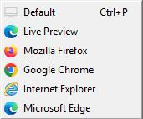

The php file will be uploaded to c:\xampp\htdocs\test\preview and the browser will open
http://localhost/test/preview/php-test.php

The browser should look like this:

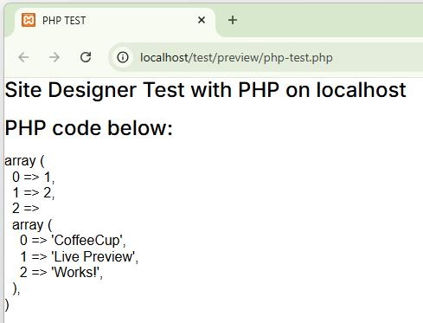

SD-380 Live Preview - Option to specify block of code before <!DOCTYPE HTML>
Added option to specify a block of code before the <!DOCTYPE HTML> declaration.
Sometimes, server-side code needs to run prior to the first line of Html.

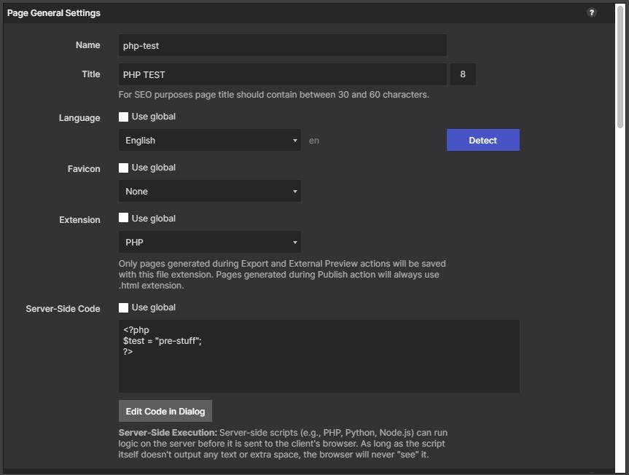

The code entered in “Server-side Code” will be placed above the Html <!DOCTYPE HTML> declaration.
Code above <!DOCTYPE HTML> must not output any text. It should only be used for server-side logic or comments.

